Terms and Conditions for guest rooms in Clare Hall accommodation
(Updated 24 April 2024)

We look forward to welcoming you to Clare Hall. Please note, when you complete your booking you enter into a legally-binding agreement with us, according to the ‘Terms and Conditions’ hereafter.

Arrival and Departure:
Check in is available from 2.00pm on the day of arrival. Our Porters’ Lodge provides a 24-hour service. In the event staff are away from the main desk, a contact number will be left for guests to call. The Porter will then return to assist with check-in and key issue.
You must vacate and check out of your room by 10.00am on the morning of your scheduled departure so we can service the room for future bookings.
Guestroom access cards/keys must be returned to the Porters’ Lodge before you leave College.
Enquiries regarding left-luggage should be directed to the Porters’ Lodge. The College has very limited storage space but we will endeavour to accommodate these requests.

Late departure Charge:
A fee equal to 50% of one night’s stay will be applied to the bill for guests checking out after 10.00am on their scheduled departure date, without prior arrangement via the Accommodation Manager. A fee equal to 100% of one night’s stay will be applied for guests who have not departed after 2.00pm on their scheduled departure date. These fees will need to be reconciled before leaving College.

Payment:
If payment is being reconciled by a department/institution, this must be arranged by forwarding a Purchase Order to our Finance team on finance@clarehall.cam.ac.uk before the reservation arrival date.
This should be communicated to the Accommodation team, who will update the Porters Lodge accordingly; and guests will not be asked for payment on arrival.
Payment by the reserved guest should be made on arrival when you check-in, by cash (up to £100) or card at the Porters’ Lodge.
Keys will not be issued until payment has been received.
Please note: we no longer accept American Express credit cards or personal/business cheques.

Cancellation by the Guest:
In the event of a cancellation, up to 14 days prior to the scheduled date of arrival, no charge will be made. Reservations cancelled within 14 days of the scheduled date of arrival will be subject to a cancellation charge equal to 30% of the booking value.
Reservations cancelled within 24 hours of the scheduled date of arrival, will be subject to the full charge of the booking value.

Cancellation by Us:
Should it become necessary for us to cancel a booking we will contact you immediately and any payments made will be refunded in full.
Should you wish us to, we will attempt to book you into another local accommodation provider (College or B&B) with a similar standard.
Should that establishment be more expensive than Clare Hall, we will pay the difference for the first night of your stay.
Our liability will not extend beyond these conditions.

Car Parking:
Guests are welcome to request car parking at Clare Hall but our availability is extremely limited and cannot be guaranteed. Residential (non-permit) parking is available on Herschel Road and the adjoining Sylvester Road.
Please note: cars parked in College are left at the owners’ risk. The College accepts no liability for any loss, damage or theft.

Change of Room:
If a booking is taken for a particular room and we subsequently find that this room is required to meet the specific needs of another guest, or it is rendered unusable due to circumstances beyond our control, we reserve the right to transfer the booking to an alternative room of similar quality.

Damage and Breakages:
Guests are responsible and liable for any breakages or damages which they cause to the accommodation or its contents. Please report these as soon as they occur, to the Porters’ Lodge.
We do not normally charge for accidental breakages, but reserve the right to charge for repair or making good if the damage is significant.

Meals:
Breakfast is not included in our room reservations, however breakfast boxes can be arranged with the Accommodation team before your arrival and these will be placed in your room.
The contents of the breakfast box are seasonal produce (subject to change) and where possible, hand-prepared in the College kitchens.
Each breakfast will include a main breakfast item (e.g. porridge), fruit juice, cereal bar, fresh fruit & yoghurt; the charge is £7.99 per box.
The College kitchens also offer an excellent lunch and dinner service during the week and you are most welcome to join our community. Please make our Catering Team aware of any dietary requirements you may wish to discuss before dining.
To dine at College you will need to purchase a meal card from the Porters’ Lodge;
3 Course – 1 Person £12.95 / 2 People £25.90 / Child (under 12) £7.20
2 Course – 1 Person £11.85
Main Course – 1 Person £8.95
The Dining Hall will take the pre-paid card and return to the Porters Lodge.

The Dining Hall is closed on weekends, and only available to College members on Wednesday evenings when our Formal Hall takes place.
Additionally, other events may also take place from time to time which preclude visitors from dining in College.
Please ask at the Porters’ Lodge for details of any restrictions to dining that may apply before you purchase your dining-cards.

Keys:
Access to your building and room will be continuous throughout your stay, using keys or key-cards provided during check-in. You are responsible for these keys or key-cards for the duration of your stay. Lost keys or key-cards will be charged at £20.00 per set.

Liability:
We do not accept any liability for any damage, loss or injury to any member of your party or any vehicles or possessions, unless proven to be caused by a negligent act by ourselves or our employees whilst acting in the course of their employment.

Lost Property:
We are happy to arrange the return of items left following departure. However, there will be a minimum charge of £10.00 to cover postage and packaging.

Pets:
Pets are not permitted in College accommodation, although assistance-dogs are welcome. Please advise us when booking if you plan to have an assistance-dog with you during your stay.

Prices:
We review our prices periodically and reserve the right to change our prices at any time. This does not affect bookings already made.

Smoking:
Smoking is NOT permitted within any part of Clare Hall. Please note that offending guests may be asked to leave immediately and may be liable for professional cleaning of any rooms and any outstanding balance of nights booked but not taken through early departure.

Weekly Fire Alarm testing:
Site wide fire alarm testing is completed every Tuesday, between 10am – 12.30pm.
College representatives attend each College building and complete a short fire alarm test, usually only lasting around 10 seconds. Guests are not required to vacate their accommodation during these tests.

Fire Drills:
Fire drills are held periodically and for their own safety the College expects all residents to take part in these.
Please familiarise yourself with the procedures which particularly apply to your accommodation, and which are posted in your guestroom. This includes the exit route and meeting point location.
If the bell in your accommodation sounds continuously, please leave the building immediately, with any guests you are responsible for and move to the building meeting point.

Termination Policy:
Clare Hall reserves the right, at its discretion, to terminate, without notice, an individual’s stay where deemed necessary through unacceptable behaviour or as a result of actions which are likely to endanger or offend others. (Please note that non-compliance of our non-smoking policy may result in immediate termination). In such circumstances no refunds will be given and any outstanding account must be settled.

VAT:
All published rates are inclusive of VAT at the current rate.

Wi-Fi Access:

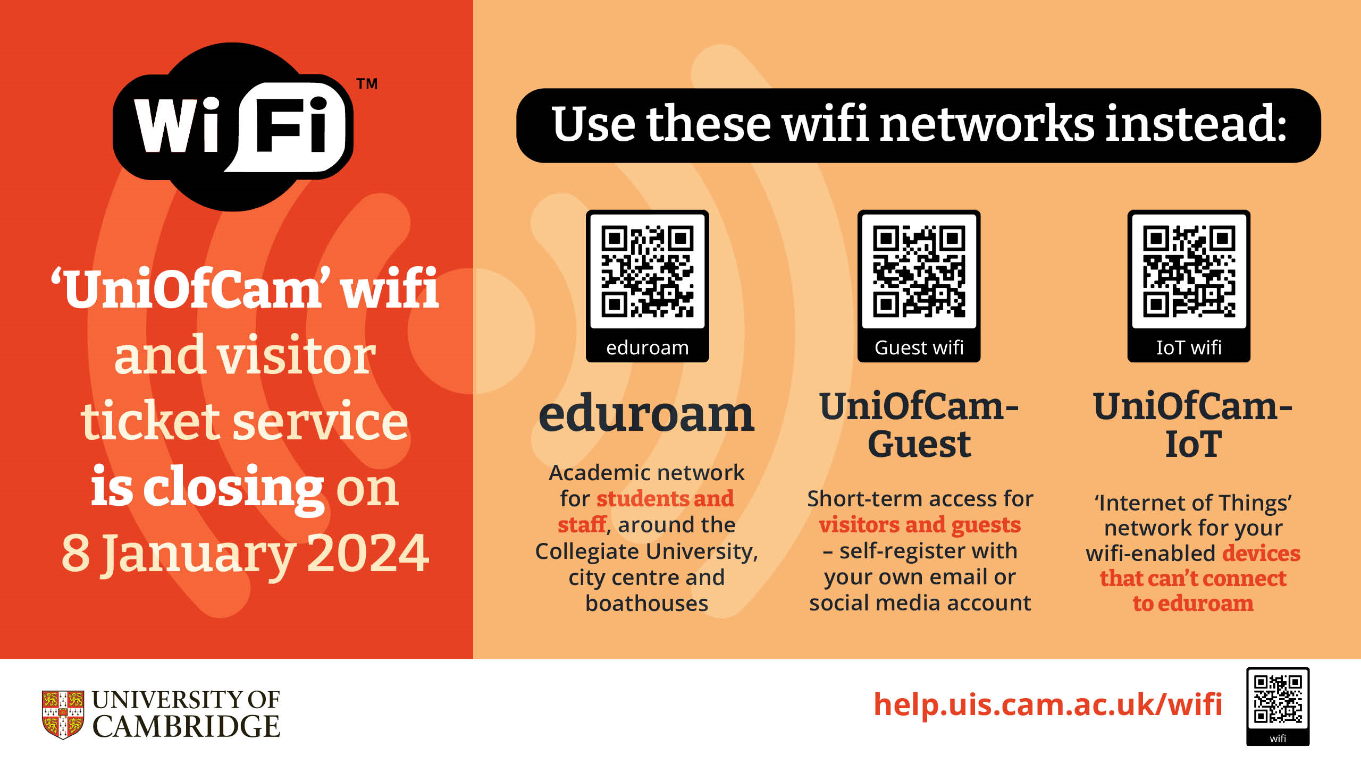

By using our Wi-Fi Service you agree to the ‘Terms and Conditions’ of use at the time.
We reserve the right to amend these ‘Terms and Conditions’ at any time.

