SDG & AI+ Academic Conferences 2026
SDG (Sustainable Development Goals) Conference: 31 July – 1 August 2026 (Fri–Sat)
AI+ (Artificial Intelligence Plus) Conference: 14 – 15 August 2026 (Fri–Sat)
Host venues:
Clare Hall, University of Cambridge
Murray Edwards College, University of Cambridge

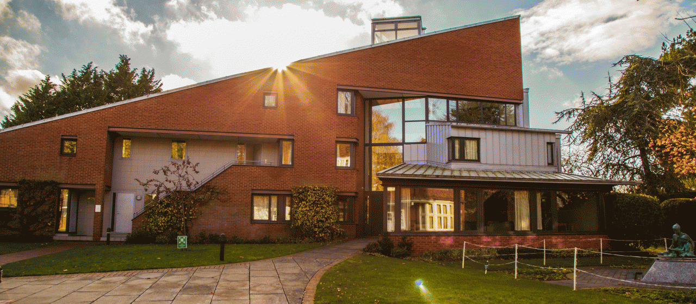
Clare Hall, University of Cambridge

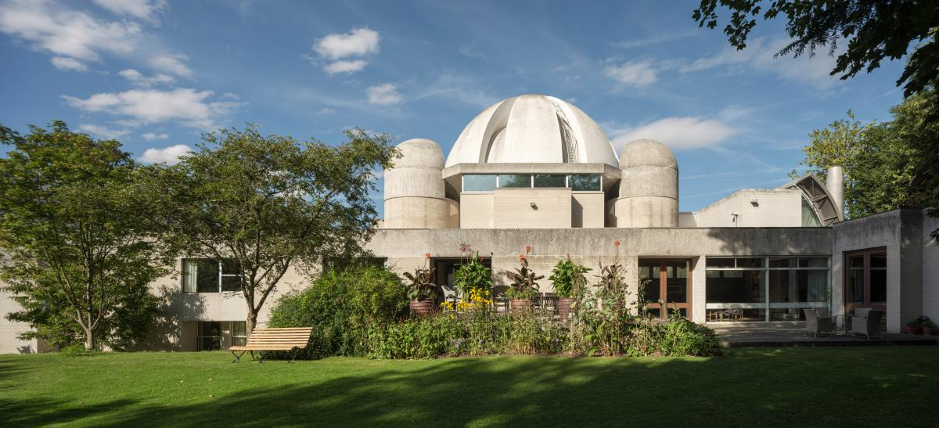
Murray Edwards College, University of Cambridge

Conference Overview
Two non-profit, peer-reviewed academic conferences focusing on SDG and AI+ will be held in summer 2026. Professor David Cope and Professor Pietro Liò, both Clare Hall fellows, will act as the Academic Chair of each conference. The conferences will be administrated and delivered by UniHive.

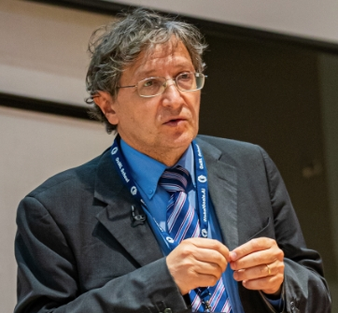
Professor David Cope Prof. Pietro Liò

The UN Sustainable Development Goals provide a shared blueprint for tackling our era’s most intertwined challenges—climate change, biodiversity loss, inequality, health, education and decent work. Yet progress hinges on credible evidence, workable finance, and accountable governance. This conference foregrounds those levers: robust disclosure and assurance, climate- and nature-related risk management, pathways for industrial decarbonisation, natural-capital accounting, and “just transition” outcomes. By convening researchers across policy, finance, engineering, ecology and the social sciences, we aim to test what truly delivers impact, identify gaps in data and indicators, and surface practical collaborations that move SDG commitments from ambition to measurable results.

AI+ looks beyond algorithms to how AI is used and what it changes across society. We focus on applications and real-world impact in health and life sciences, education and skills, public services and cities, creative industries, finance and law, climate and the environment—alongside the governance, safety, fairness, and accountability needed for trustworthy deployment. Topics include evaluation in the wild, human-AI collaboration and accessibility, data stewardship and privacy, robustness and risk management, policy and regulation, labour and productivity effects, and inclusion to ensure benefits are broadly shared. By bringing technologists together with domain experts, policymakers, and civil society, AI+ emphasises evidence of outcomes, not just technical novelty—so AI advances translate into measurable public value.

Each conference is a two-day, scholar-led meeting featuring keynotes, invited talks, and posters. Talk/Poster titles and abstracts will appear online, and slides/recordings will be shared only with presenter consent.

Pre-Conference Summer School
Prior to the conferences, two dedicated UniHive summer schools held at Clare Hall, Murray Edwards College and other Colleges will provide training and networking opportunities for students and early career researchers in areas related to the themes of the conferences. Chairs of both conferences and other senior Cambridge academics will be offering lectures and seminars to nurture and expand participants’ interest, knowledge, research and academic skills in relevant areas.

Conference Chairs
• Academic Chair – SDG: Prof. David Cope
• Academic Chair – AI+: Prof. Pietro Liò
• Organising Committee Chair: Prof. Casimir d’Angelo
• Organising Committee Deputy Chair: Dr. Ruigang Michael Zhou

SDG Conference
Dates: 31 July – 1 August 2026
Chair: Prof. David Cope

Invited Speakers:
Prof. Matthew Grimes, Professor of Entrepreneurship and Sustainable Futures, University of Cambridge
Prof. Patrick Baert, Professor of Social Theory, University of Cambridge
Prof. Geoff Hayward, Professor of Education, University of Cambridge
Prof. Catherine Barnard, Professor of European Law, University of Cambridge
Prof. Andy Woods, Head of Institute for Energy & Environmental Flows , University of Cambridge
… and more

Themes
• Integrating the UN Sustainable Development Goals across policy, science, and practice
• Financing for sustainable development & risk (public/private, blended finance)
• Climate action, biodiversity, and nature-positive transitions
• Just transition, inclusion, and social outcomes (health, education, inequality)
• Social entrepreneurship and corporate responsibility
• Governance, regulation and law framework
• Renewable energy landscape and environmental science
And more…

Call for Papers
• Formats: Full papers for Presentation or Abstracts for Poster, in English.
• Review: Double-blind; 2 reviews per submission.
• Display: Accepted titles and abstracts will appear online; slides/recordings shared with consent.

Important Dates
• Call for Papers opens: 30 January 2026
• Poster abstract / Paper deadline: 30 April 2026
• Decisions: rolling basis
• Conference: 31 July – 1 August 2026

Programme Outline
Day 1 (Friday, 31 July 2026)
Morning
– Registration & Coffee
– Keynotes
– Presentation Session
Afternoon
– Keynote
– Parallel Sessions A (Presentation Session / Summer School Student Poster Session)
– Reception

Day 2 (Saturday, 1 August)
Morning
– Parallel Sessions B (Presentation Session / Poster Session)
Afternoon
– Panel Discussion
– Gala Dinner (Awards & Closing)

AI+ Conference
Dates: 14 – 15 August 2026
Chair: Prof. Pietro Liò

Invited Speakers:
Prof. Nic Lane, Professor of Machine Learning Systems, University of Cambridge
Prof. Jason Robinson, Professor of Materials Physics, University of Cambridge
Prof. Thomas Krieg, Professor for Experimental Cardiovascular Medicine, University of Cambridge
Prof. John Orr, Professor of Structural Engineering, University of Cambridge
Prof. Shasha Lu, Associate Professor in Marketing, University of Cambridge
… and more

Themes
• AI for science & graph neural networks
• Multimodal & vision
• Responsible AI & societal impact in various areas including:
-Advanced manufacturing and engineering
-AI-driven development of medicine, biomedicine, etc.
-Smart city and infrastructure
-AI in finance (big data)
-Machine learning in materials science
And more…

Call for Papers
• Formats: Full papers for Presentation or Abstracts for Poster, in English.
• Review: Double-blind; 2 reviews per submission.
• Display: Accepted titles and abstracts will appear online; slides/recordings shared with consent.

Important Dates
• Call for Papers opens: 30 January 2026
• Poster abstract / Paper deadline: 30 April 2026
• Decisions: rolling basis
• Conference: 14 – 15 August 2026

Programme Outline
Day 1 (Friday, 14 August 2026)
Morning
– Registration & Coffee
– Keynotes
– Presentation Session
Afternoon
– Keynote
– Parallel Sessions A (Presentation Session / Summer School Student Poster Session)
– Reception

Day 2 (Saturday, 15 August 2026)
Morning
– Parallel Sessions B (Presentation Session / Poster Session)
Afternoon
– Panel Discussion
– Gala Dinner (Awards & Closing)

Registration
Please submit your registration through https://forms.office.com/e/JzpMCzqZrq, or scan the QR code below:

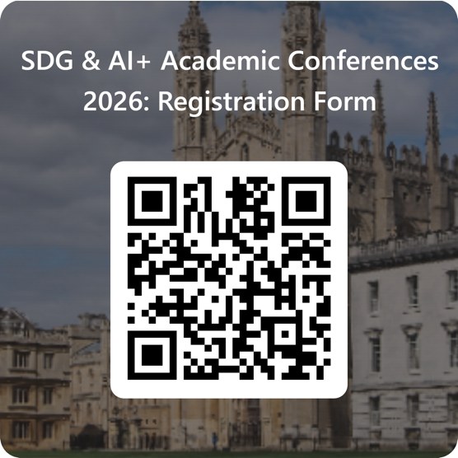

The Organising Committee will be in touch to complete the registration. The registration fees are:

Students £180 | Faculty £300| Industry £500

The fee covers full participation in the conference, including tea/coffee break, lunch, and dinners. The conferences are non-profit events; any surplus supports student awards and accessibility.

Accommodation
Participants are welcome to book their own accommodation. The Organising Committee can offer limited number of discounted accommodation on a first come first served basis.

Policies (apply to both conferences)
• Peer review: Double-blind; 2–3 reviews per submission; conflict-of-interest screening enforced.
• Responsible research & AI use: Language/model assistance must be disclosed; fabrication or falsification is prohibited.
• Data & privacy: UK GDPR compliant; minimal data capture; recording only with explicit consent.
• Code of Conduct: Zero tolerance for harassment; clear reporting and response pathways.
• Accessibility: Captions in plenary, hearing loop available, step-free routes and reserved seating, quiet room; dietary labelling at catered functions.

Contact
Conference address:
Attn: Prof. David Cope
Clare Hall, University of Cambridge
Herschel Road
Cambridge CB3 9AL
United Kingdom

Organising Committee - UniHive
Email: info@unihive.education
Phone: +44 1223 776118

